**Get NVMe support on unsupported bios with BIOS modding**

**Topic**

1. **BIOS MODIFY**

**My testing system**

* **Motherboard AsRock H77 Pro4/MVP**
* **CPU Intel i5-3570**

**My motherboard is not support NVMe in PCI slot by factory so I had to modified BIOS by my self**

**1.BIOS MODIFY**

**What you need**

* **Your BIOS file (get from your mainboard’s website)**
* **UEFITool.exe**
* **NvmExpressDxe_4.ffs**

**Step**

1. **Open UEFITool.exe**

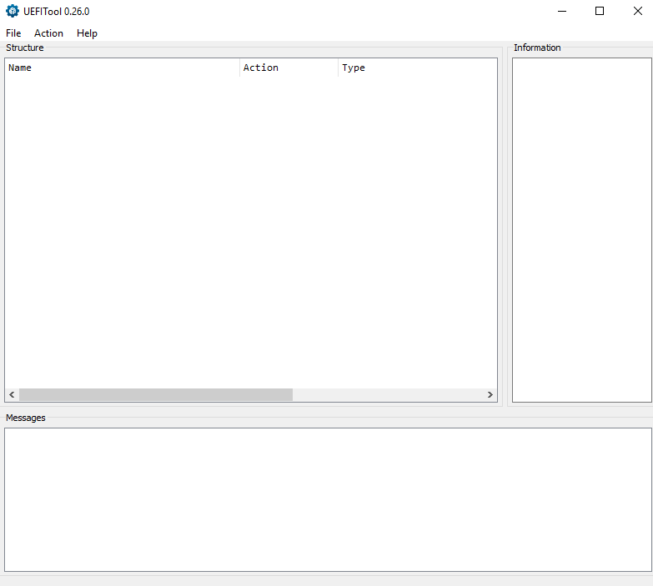

1. **Click File > Open image file…**

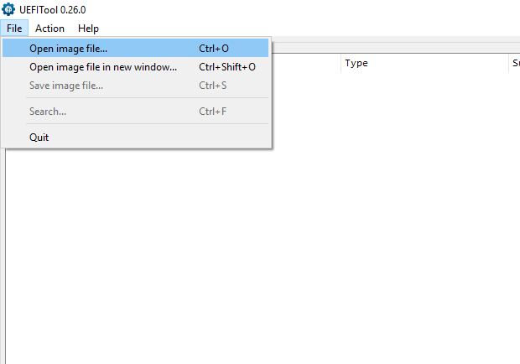

1. **Select your BIOS file**

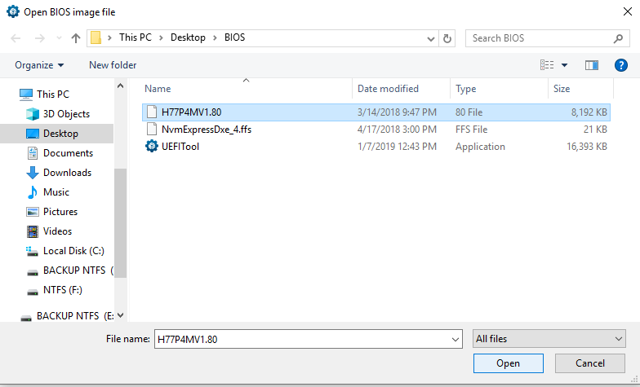

1. **Click on Intel > BIOS region**

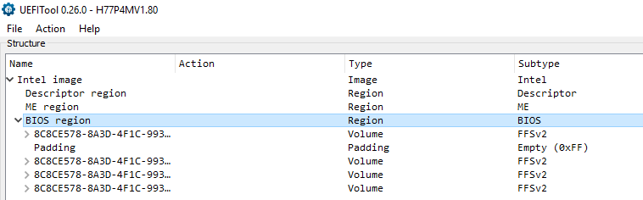

1. **Click File > Search**

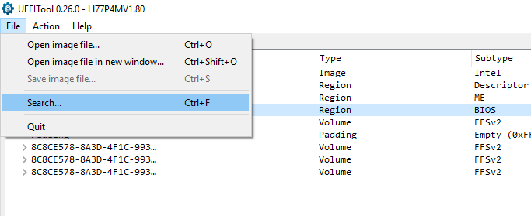

1. **Click on Text tab > Search for “DXE”**

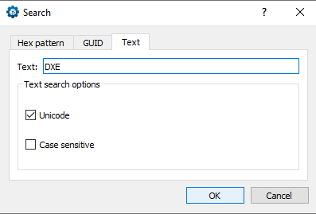

1. **Double click on the last one**

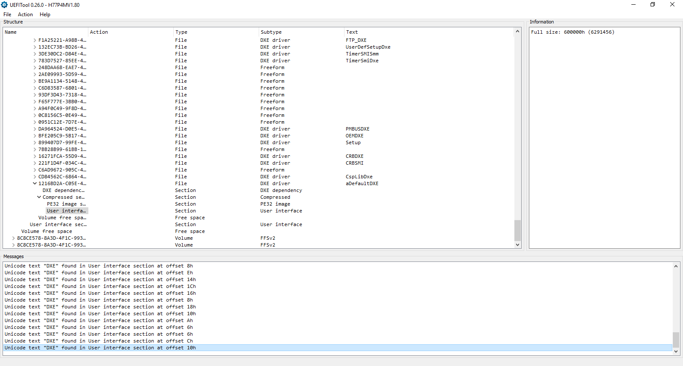

1. **Scroll to the first on sub-folder**

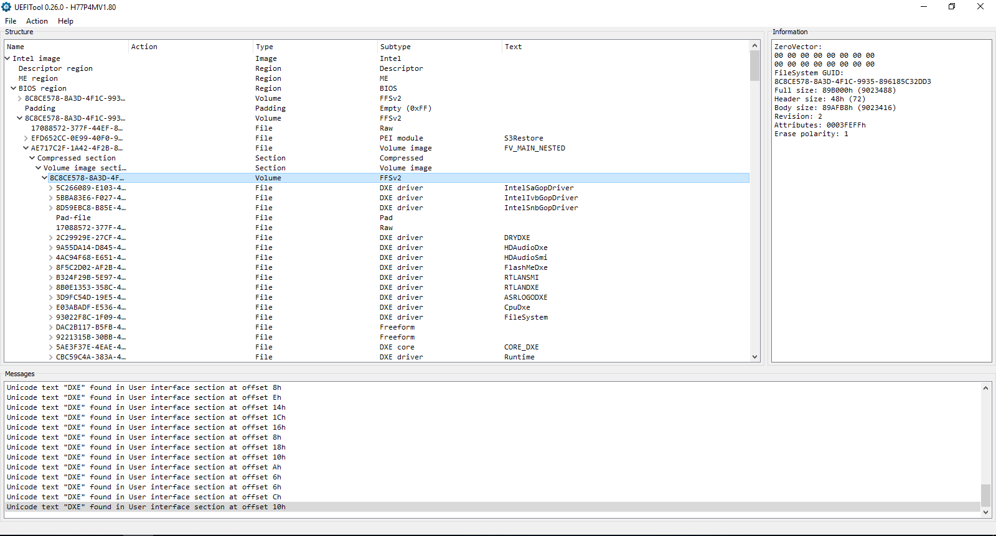

1. **Scroll to the last one before free space**
2. **Click Insert after…**

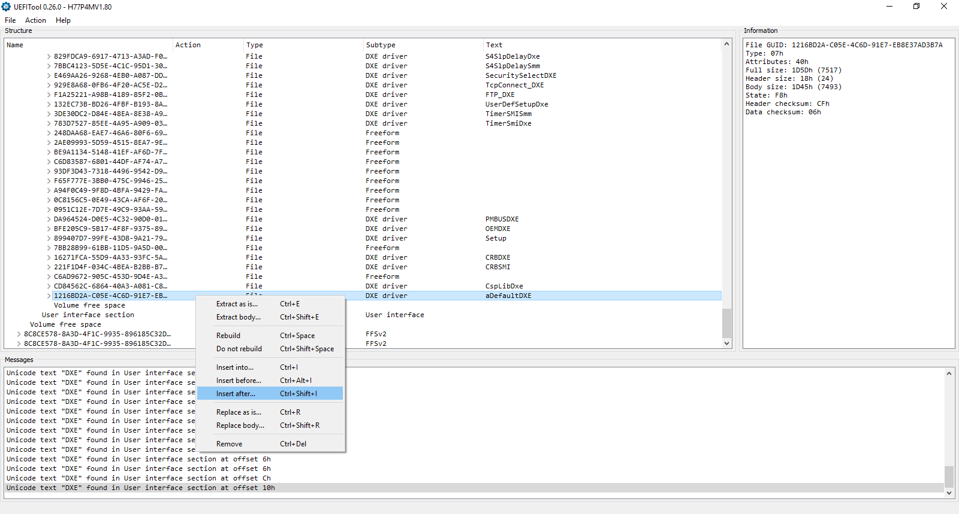

1. **Select NvmExpressDxe_4.ffs**

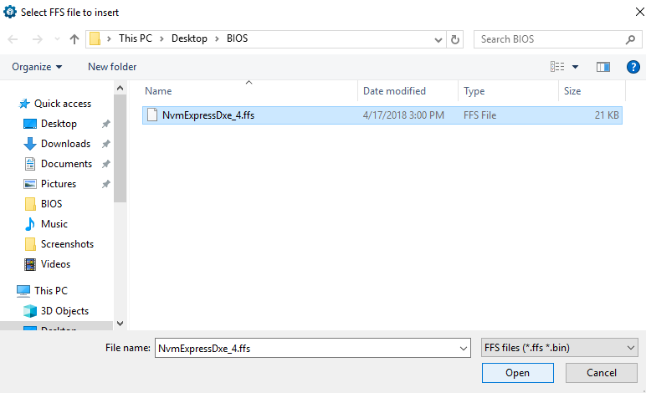

1. **It should look like this**

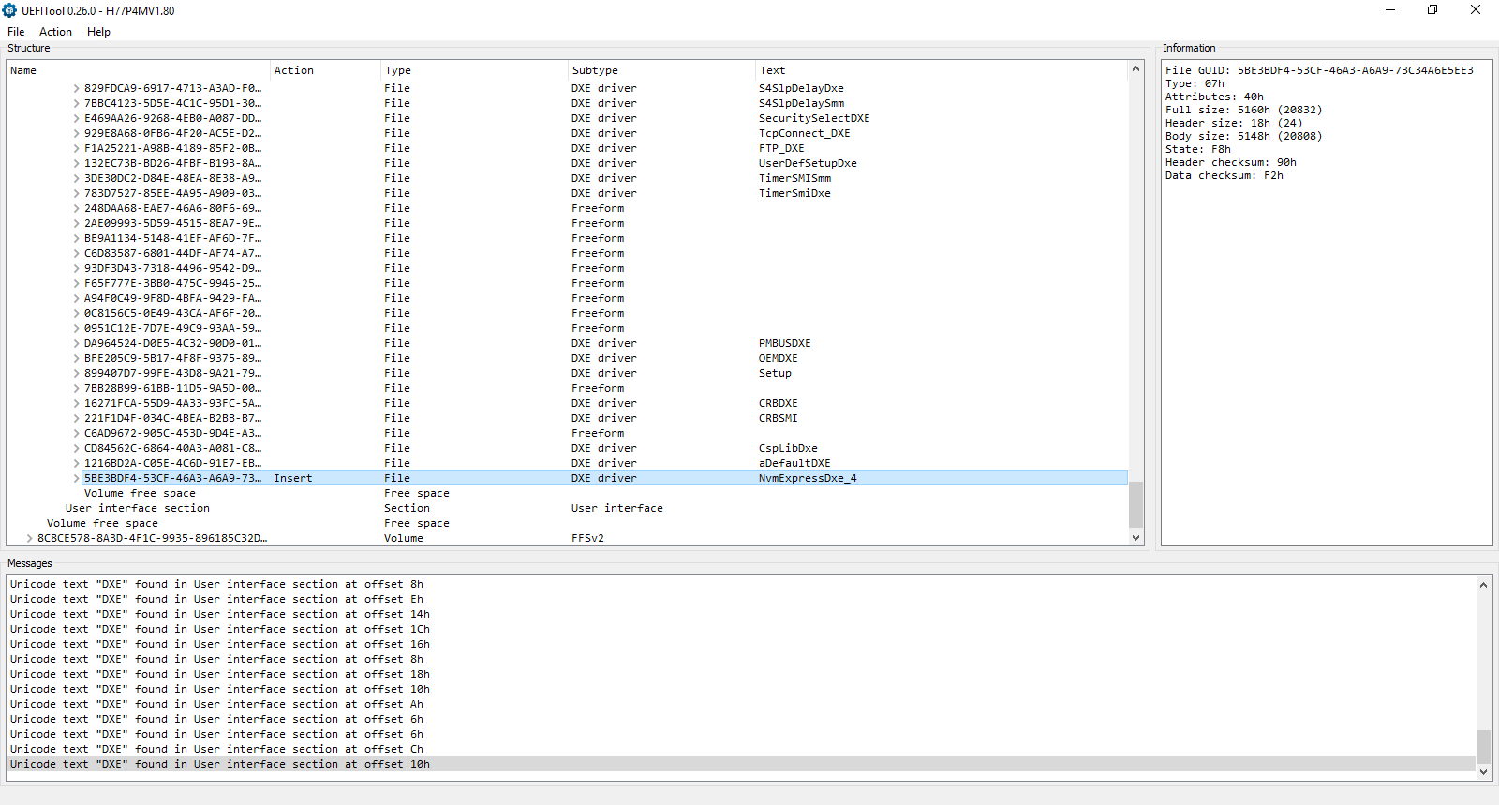

1. **Click at File > Save image file…**

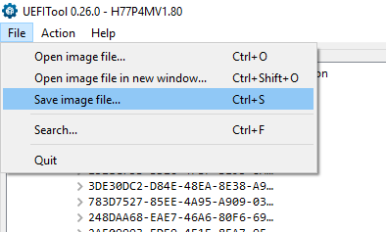

1. **I had to remove .mod file extensions as my unmodified BIOS does’t have**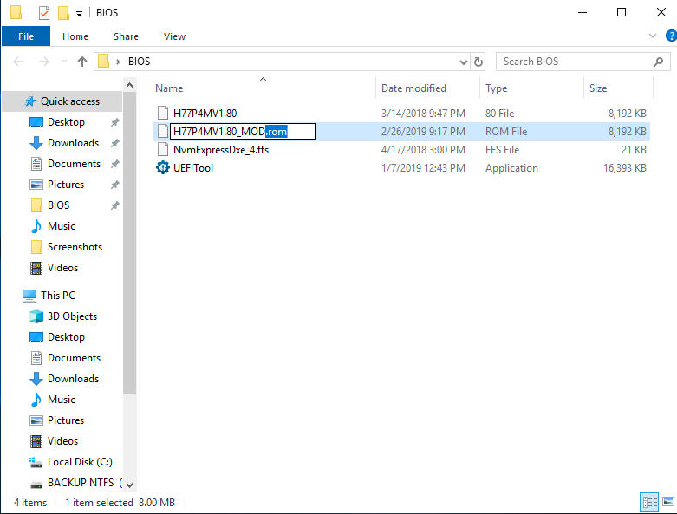
2. **DONE FOR MODIFY BIOS STEP**

**2.BIOS FLASHING**

1. **Boot into BIOS setting > Instant Flash**

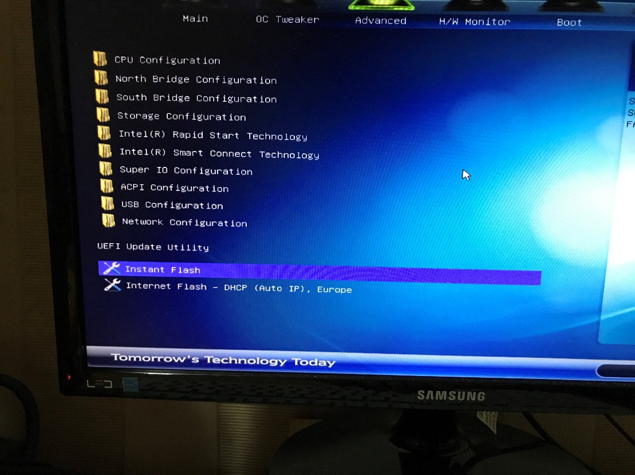

1. **Select your BIOS file**

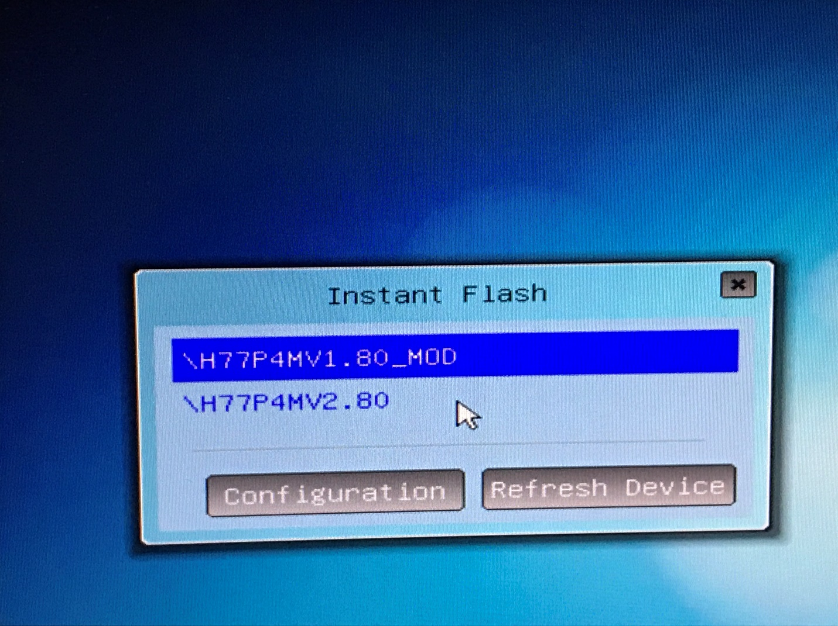

1. **Wait for it**

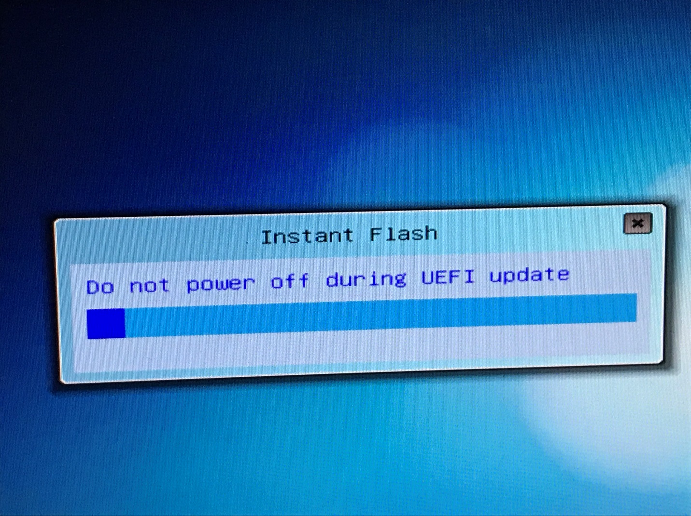

1. **Reboot**

